1)The project is done using java 17,Spring boot,rest and maven as build tool .
Also database used is h2 in memory database.u can add the dependency in pom.xml for h2. Import as maven project in the ides Eclipse/Intellij and run the BankingTransactionProcessor as a java application(it’s a sping boot application).
2)Alternatively run mvn clean install on the project folder which has the pom.xml
3) Open the target folder. Use “BankingTransactionProcessor-0.0.1-SNAPSHOT.jar” from the target folder from repo. Else use the jar from “Application Jar” which is also “BankingTransactionProcessor-0.0.1-SNAPSHOT.jar”and follow below steps
4) run the cmd java -jar BankingTransactionProcessor-0.0.1-SNAPSHOT.jar in command line.
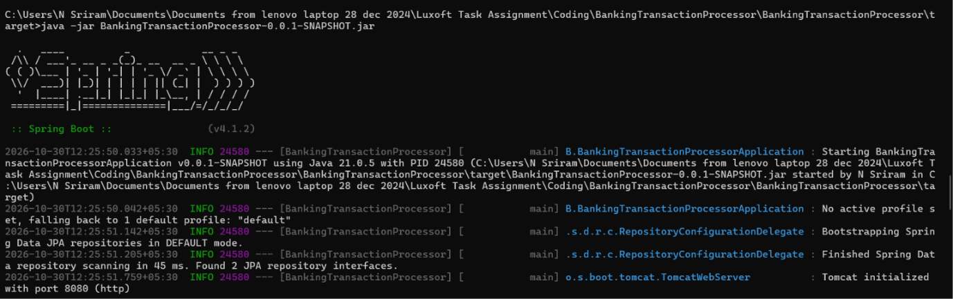

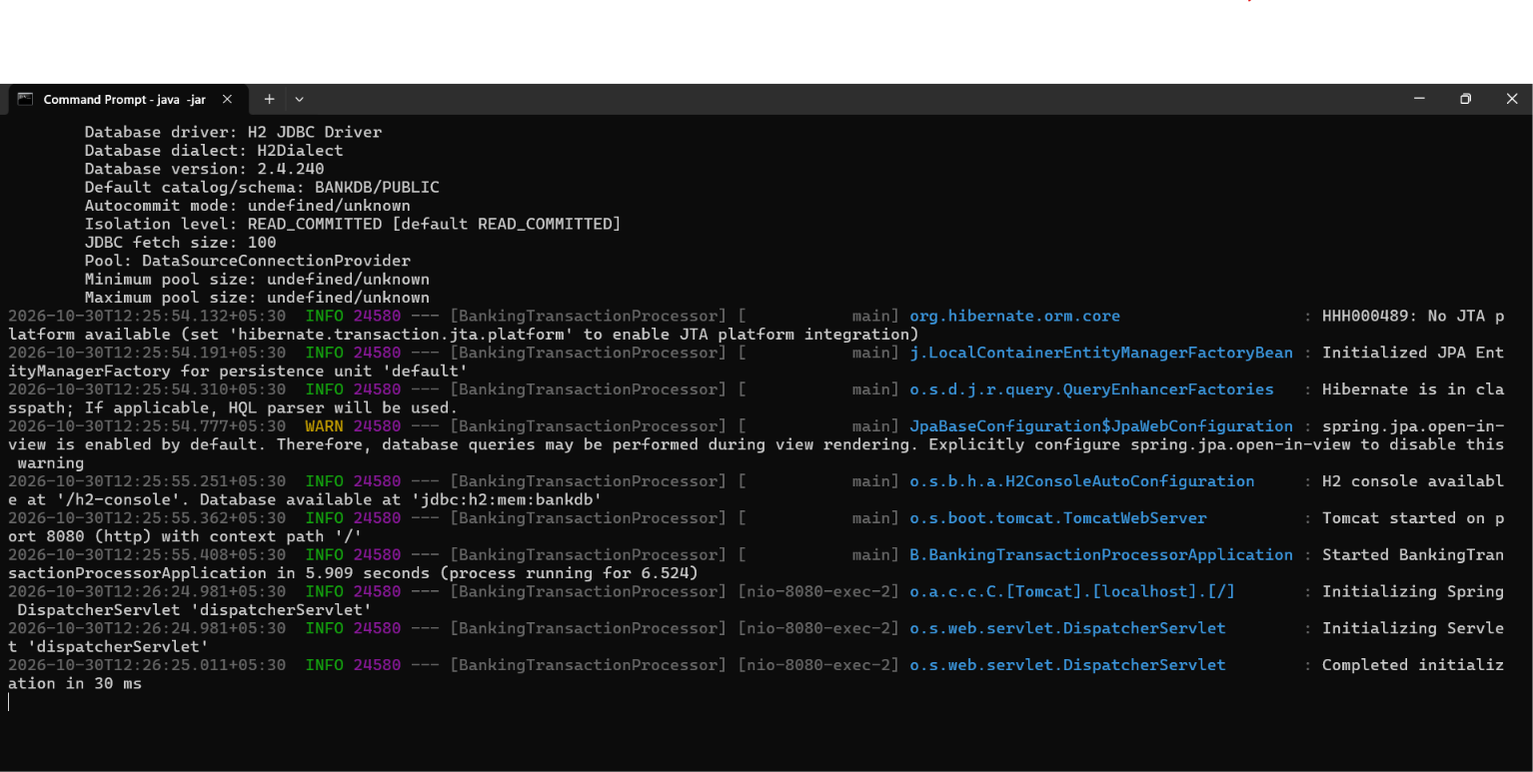

5) server port is set to 8080 .
6) Tools used:Postman, http://localhost:8080/h2-console,Intellij,Maven
http://localhost:8080/h2-console
pls see the below image for config

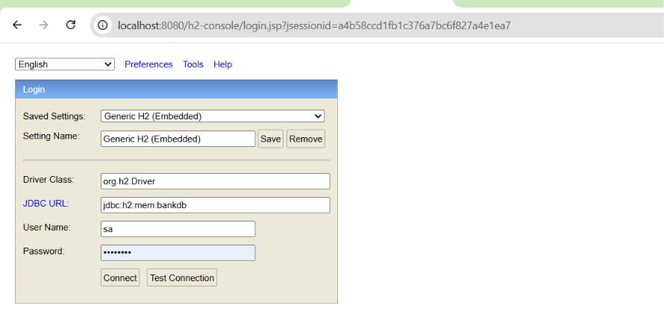

Password is: password

The h2 console

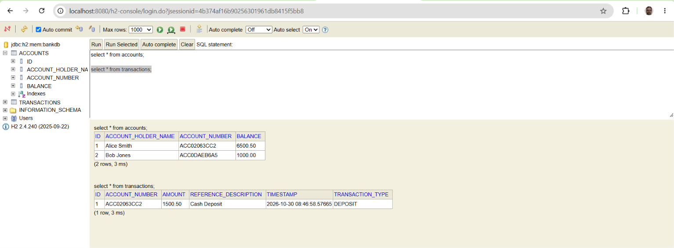

7) Each Rest Api created can be deployed as microservice in Kubernetes.Test the microservices using below steps.Also present all request as postman collection. Its present in “Postman Collection” folder.Import in postman and can also use for testing.
1. Create Account 1 (Alice)
- Method: POST
- URL: http://localhost:8080/api/bank/accounts
- Headers: Content-Type: application/json
- Body (raw JSON):
json
{
"accountHolderName": "Alice Smith",
"initialBalance": 5000.00
}

Response:
{
"id": 1,
"accountNumber": "ACC02063CC2",
"accountHolderName": "Alice Smith",
"balance": 5000.00
}

Postman Screenshot

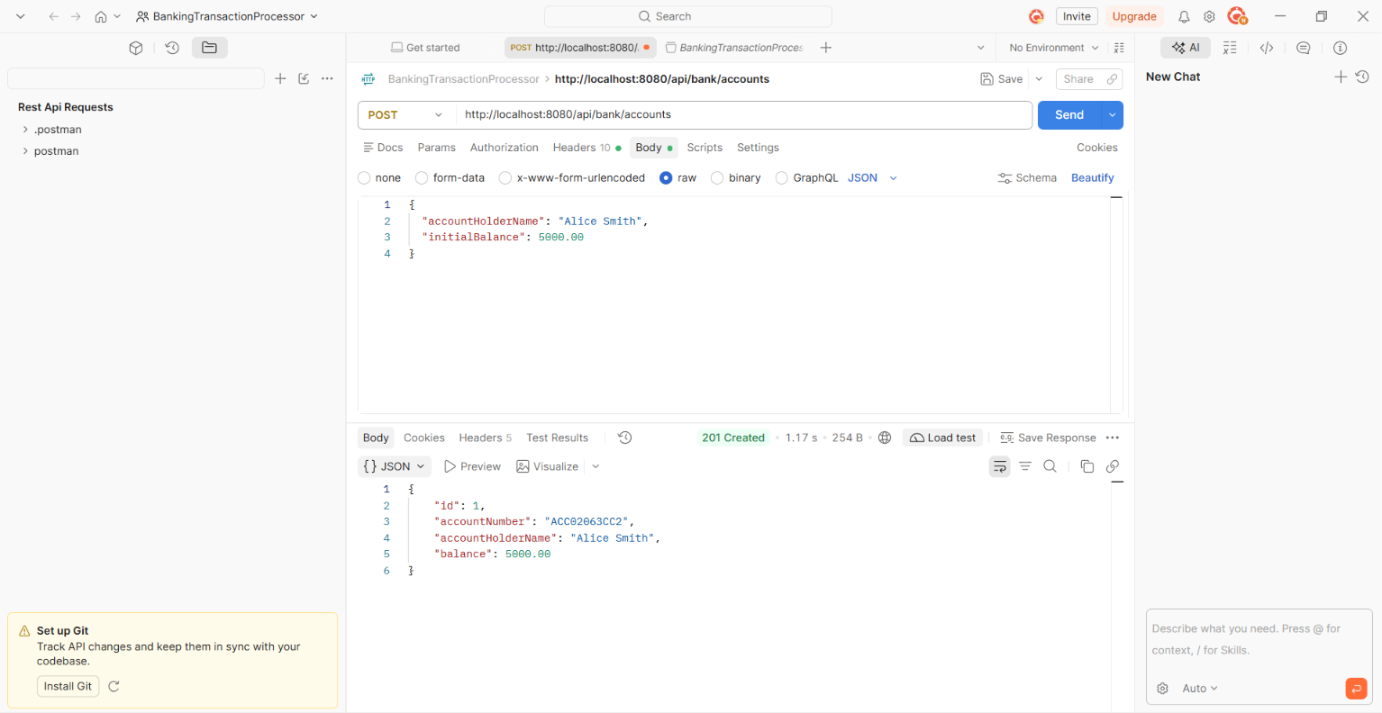

In mem db h2 db accounts table record created.
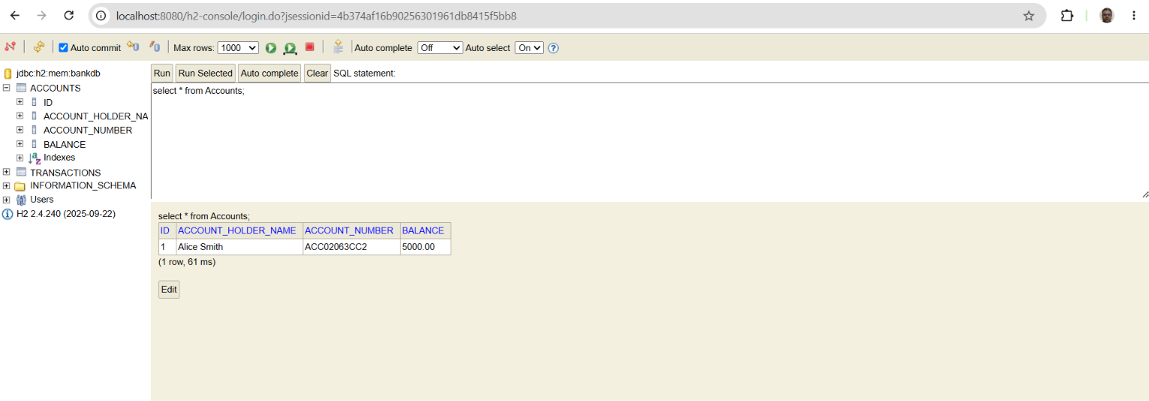

2. Create Account 2 (Bob)
- Method: POST
- URL: http://localhost:8080/api/bank/accounts
- Headers: Content-Type: application/json
- Body (raw JSON):
json
{
"accountHolderName": "Bob Jones",
"initialBalance": 1000.00
}
Response:

{
"id": 2,
"accountNumber": "ACC0DAEB6A5",
"accountHolderName": "Bob Jones",
"balance": 1000.00
}

Postman Screenshot

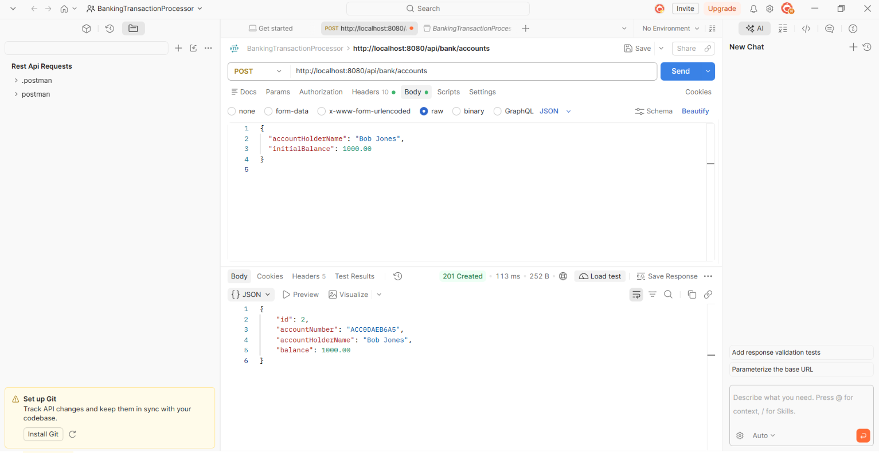

H2 in mem for accounts table with new record created for Bob

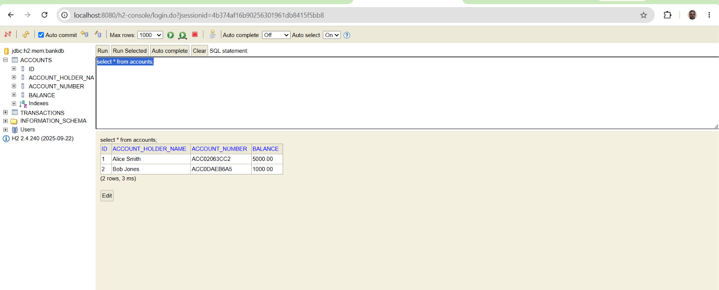

3. View Alice's Account Profile
- Method: GET
- URL: http://localhost:8080/api/bank/accounts/{{active_account}}
- : http://localhost:8080/api/bank/accounts/{ACC02063CC2}
Response:
Account details of Alice
{
"id": 1,
"accountNumber": "ACC02063CC2",
"accountHolderName": "Alice Smith",
"balance": 5000.00
}

Postman

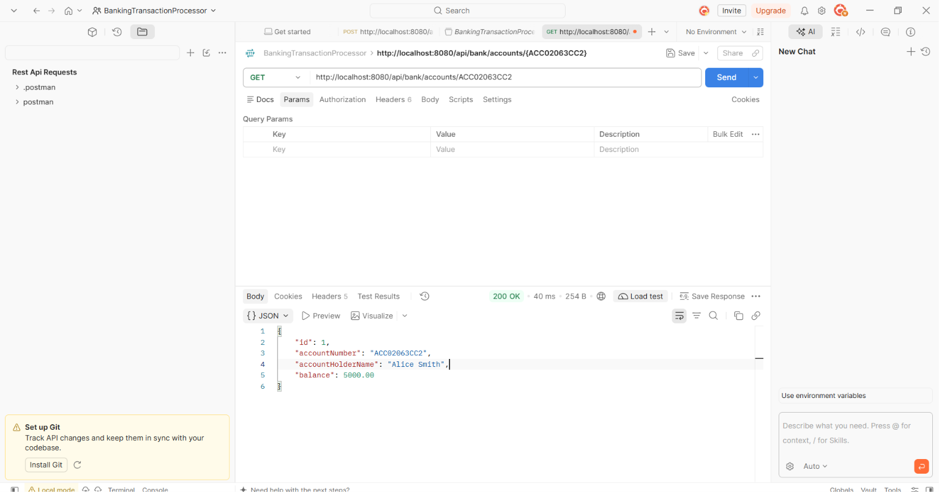

4. Deposit Funds
- Method: POST
- URL: http://localhost:8080/api/bank/accounts/{{active_account}}/deposit
- http://localhost:8080/api/bank/accounts/ ACC02063CC2/deposit
- Headers: Content-Type: application/json
- Body (raw JSON):

json
{
"amount": 1500.50
}

Response

{
"id": 1,
"accountNumber": "ACC02063CC2",
"accountHolderName": "Alice Smith",
"balance": 6500.50
}
Postman

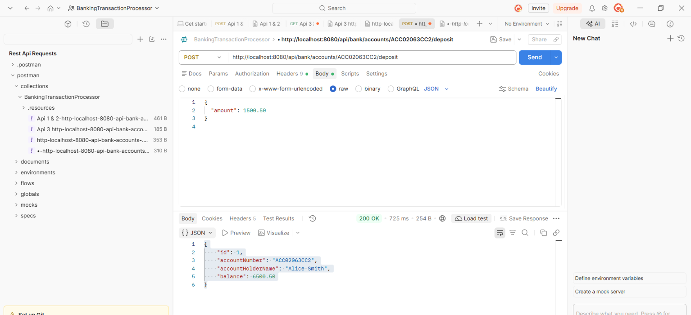

H2 in mem db for accounts and transaction table
5. Withdraw Funds
- Method: POST
- URL: http://localhost:8080/api/bank/accounts/{{active_account}}/withdraw
- Headers: Content-Type: application/json
- URL: http://localhost:8080/api/bank/accounts/ACC02063CC2/withdraw
- Body (raw JSON):
json
{
"amount": 200.00
}

Response

{
"id": 1,
"accountNumber": "ACC02063CC2",
"accountHolderName": "Alice Smith",
"balance": 6300.50
}

Postman

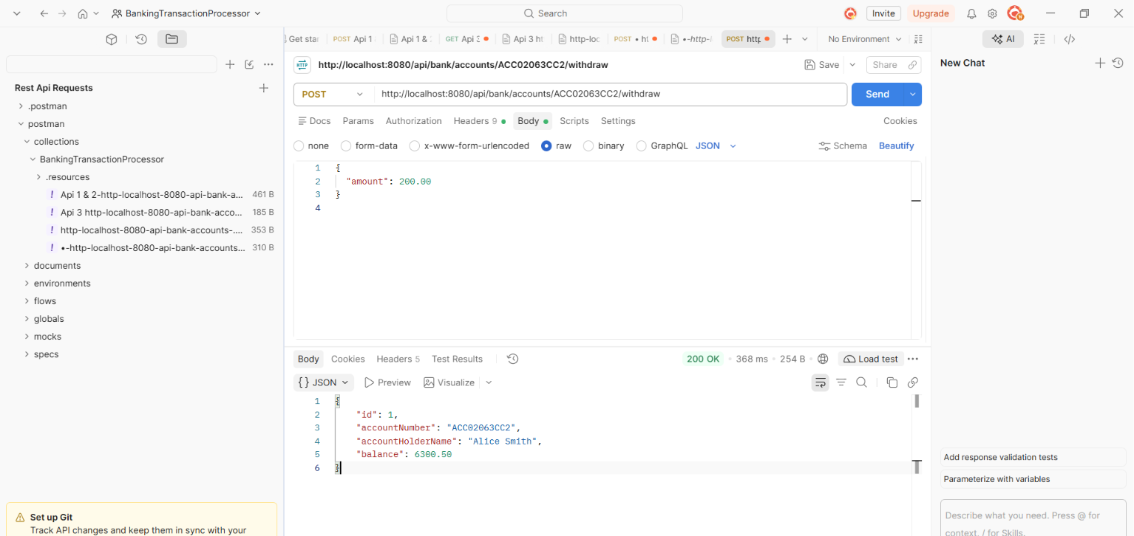

H2 in mem table updated

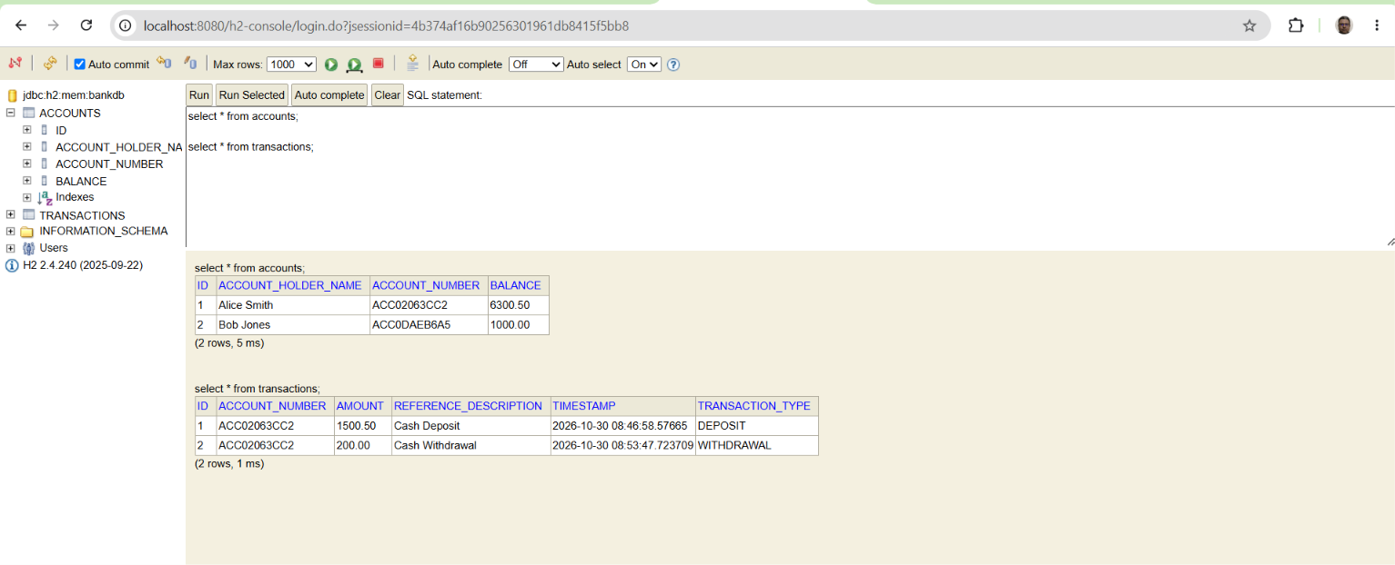

6. Transfer to Bob
- Method: POST
- URL: http://localhost:8080/api/bank/accounts/{{active_account}}/transfer
- Headers: Content-Type: application/json
- Body (raw JSON): Replace ACCXXXXX with Bob's generated account string from step 2.
http://localhost:8080/api/bank/accounts/ ACC02063CC2/transfer
json
{
"toAccountNumber": "ACC0DAEB6A5",
"amount": 1000.00
}
Transfer execution completed successfully.
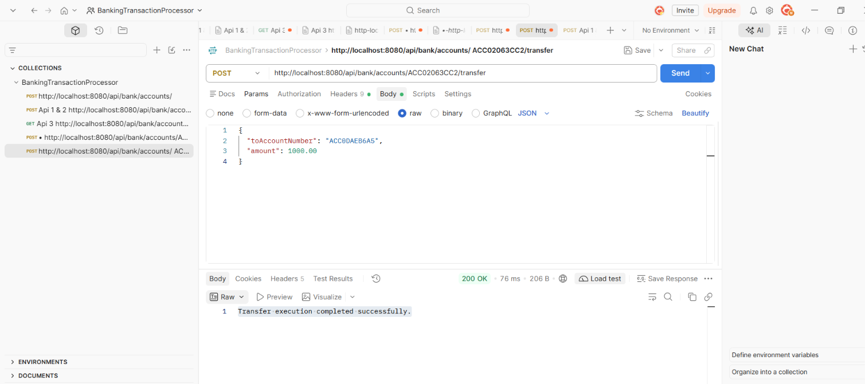

GET http://localhost:8080/api/bank/accounts/ACC02063CC2

Response

{
"id": 1,
"accountNumber": "ACC02063CC2",
"accountHolderName": "Alice Smith",
"balance": 5300.50
}
Postman

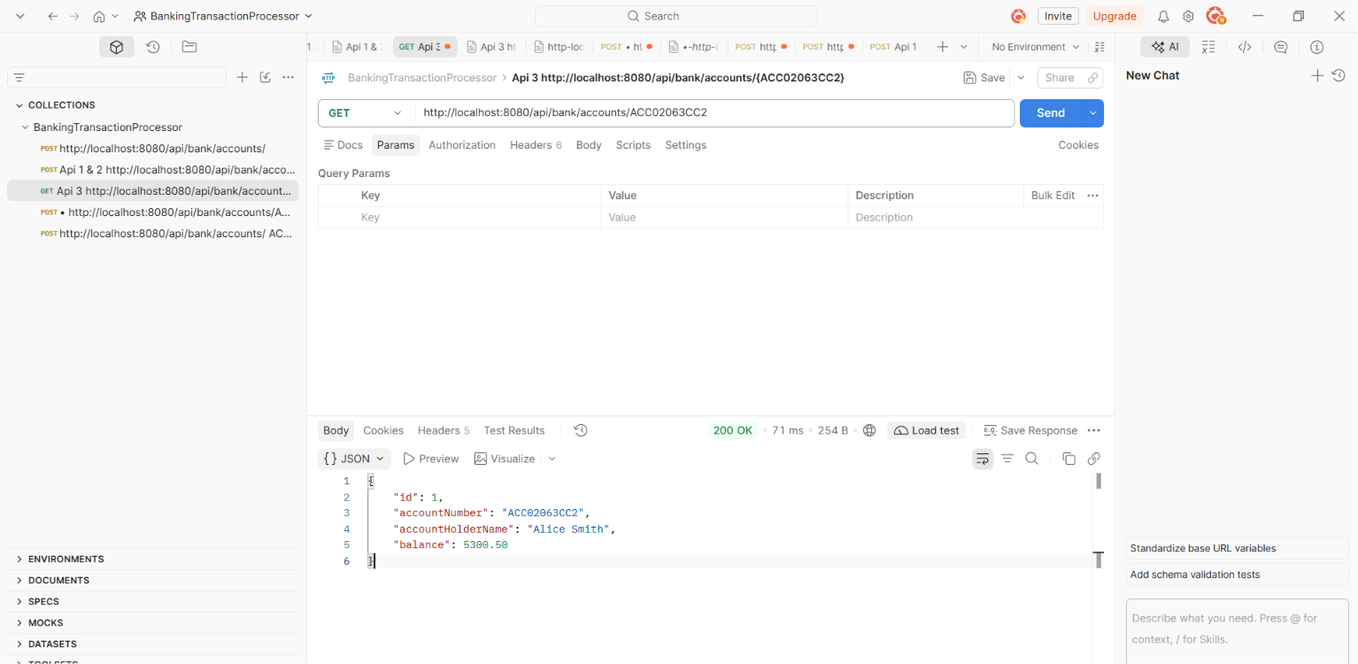

GET http://localhost:8080/api/bank/accounts/ACC0DAEB6A5

Response

{
"id": 2,
"accountNumber": "ACC0DAEB6A5",
"accountHolderName": "Bob Jones",
"balance": 2000.00
}
postman

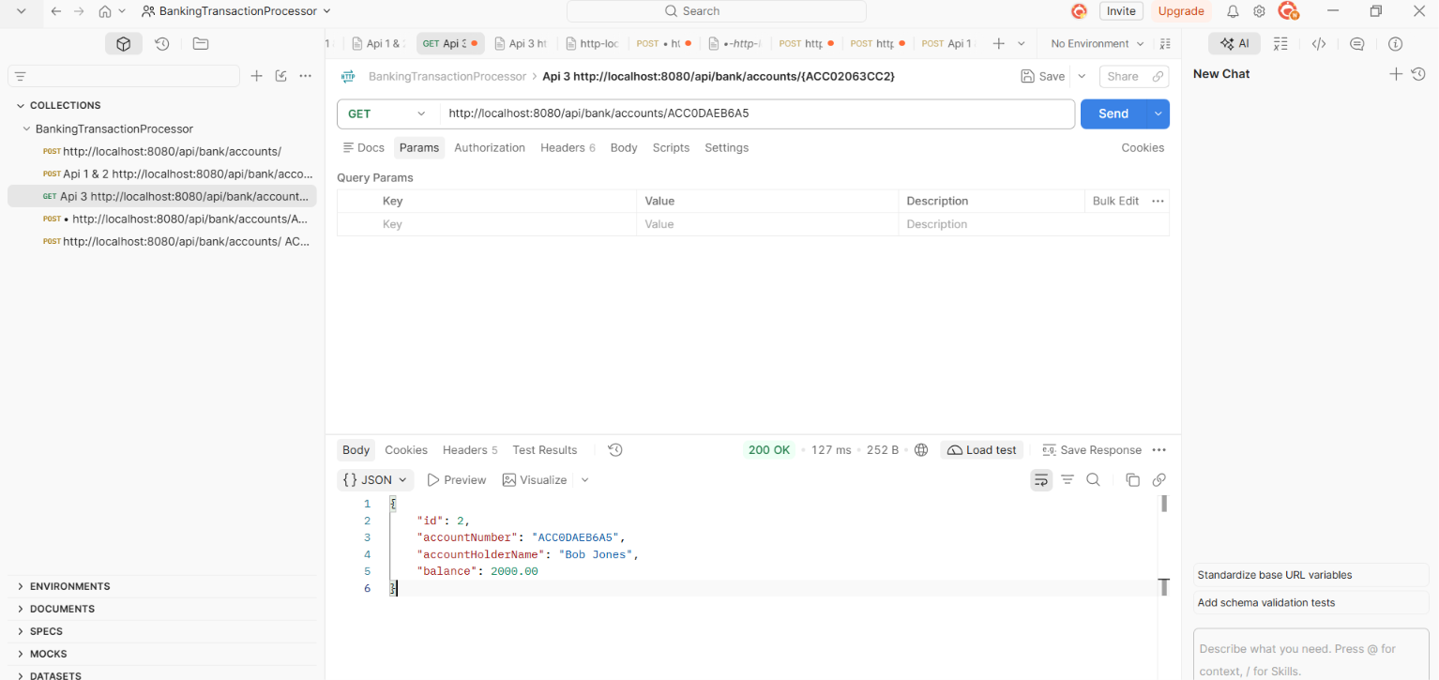

In memory h2
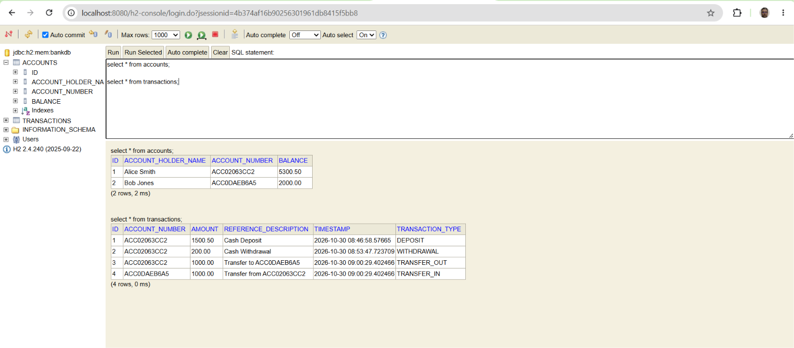

7. Get Transaction History Statement
- Method: GET
URL: http://localhost:8080/api/bank/accounts/{{active_account}}/transactions

http://localhost:8080/api/bank/accounts/ACC02063CC2/transactions

Response

[
{
"id": 3,
"accountNumber": "ACC02063CC2",
"transactionType": "TRANSFER_OUT",
"amount": 1000.00,
"timestamp": "2026-10-30T09:00:29.402466",
"referenceDescription": "Transfer to ACC0DAEB6A5"
},
{
"id": 2,
"accountNumber": "ACC02063CC2",
"transactionType": "WITHDRAWAL",
"amount": 200.00,
"timestamp": "2026-10-30T08:53:47.723709",
"referenceDescription": "Cash Withdrawal"
},
{
"id": 1,
"accountNumber": "ACC02063CC2",
"transactionType": "DEPOSIT",
"amount": 1500.50,
"timestamp": "2026-10-30T08:46:58.57665",
"referenceDescription": "Cash Deposit"
}
]
Postman
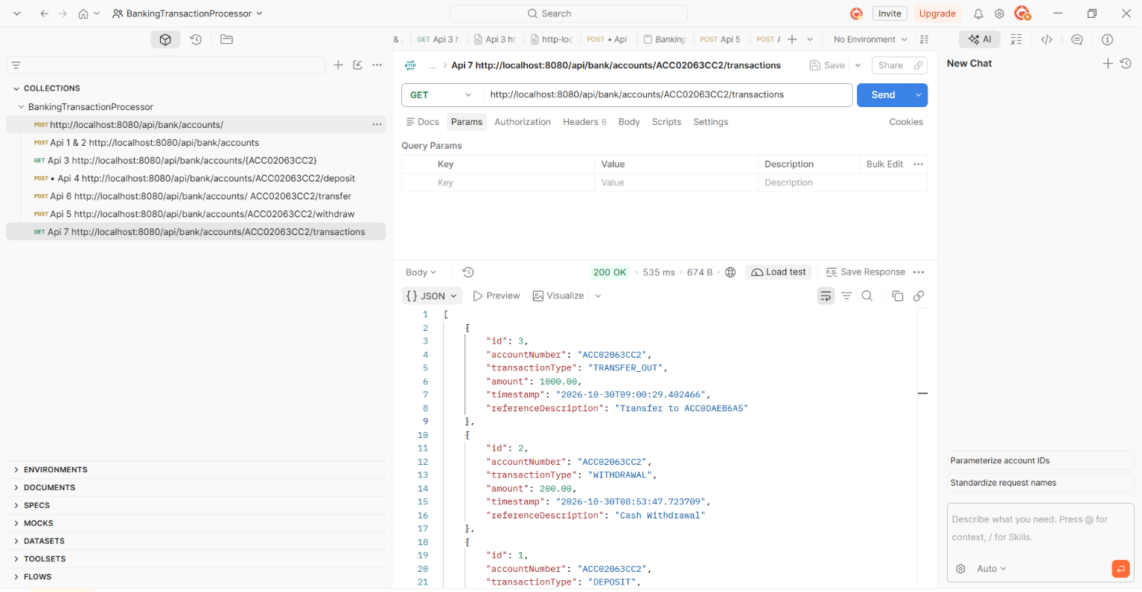

H2 in mem transactions table
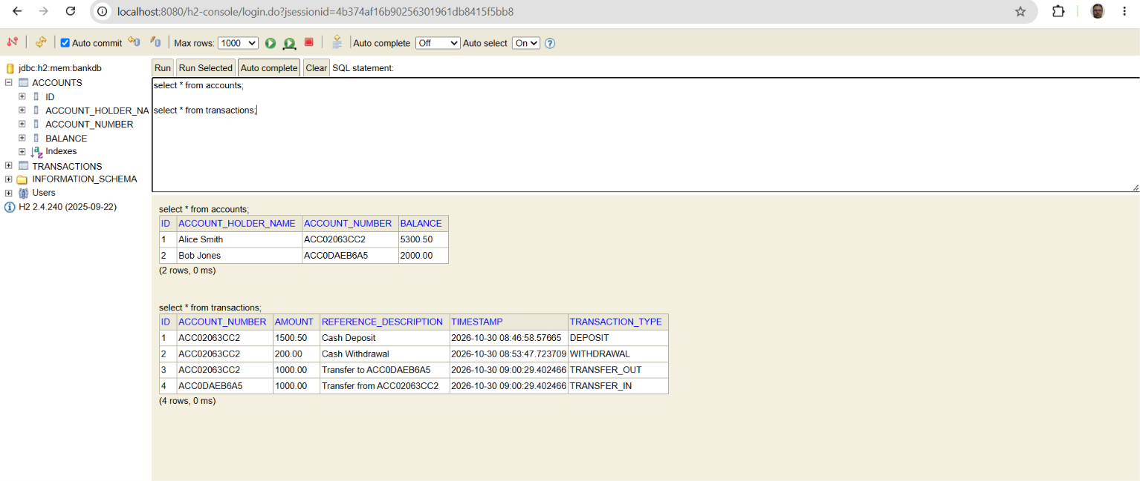

8. Trigger Insufficient Funds (400 Bad Request)
- Method: POST
- URL: http://localhost:8080/api/bank/accounts/{{active_account}}/withdraw
- Headers: Content-Type: application/json
- Body (raw JSON):
- URL: http://localhost:8080/api/bank/accounts/ACC02063CC2/withdraw

json
{
"amount": 9999999.00
}
Response

{
"error": "Insufficient funds for withdrawal.",
"timestamp": "2026-10-30T09:43:40.2386641",
"status": 400
}
Postman

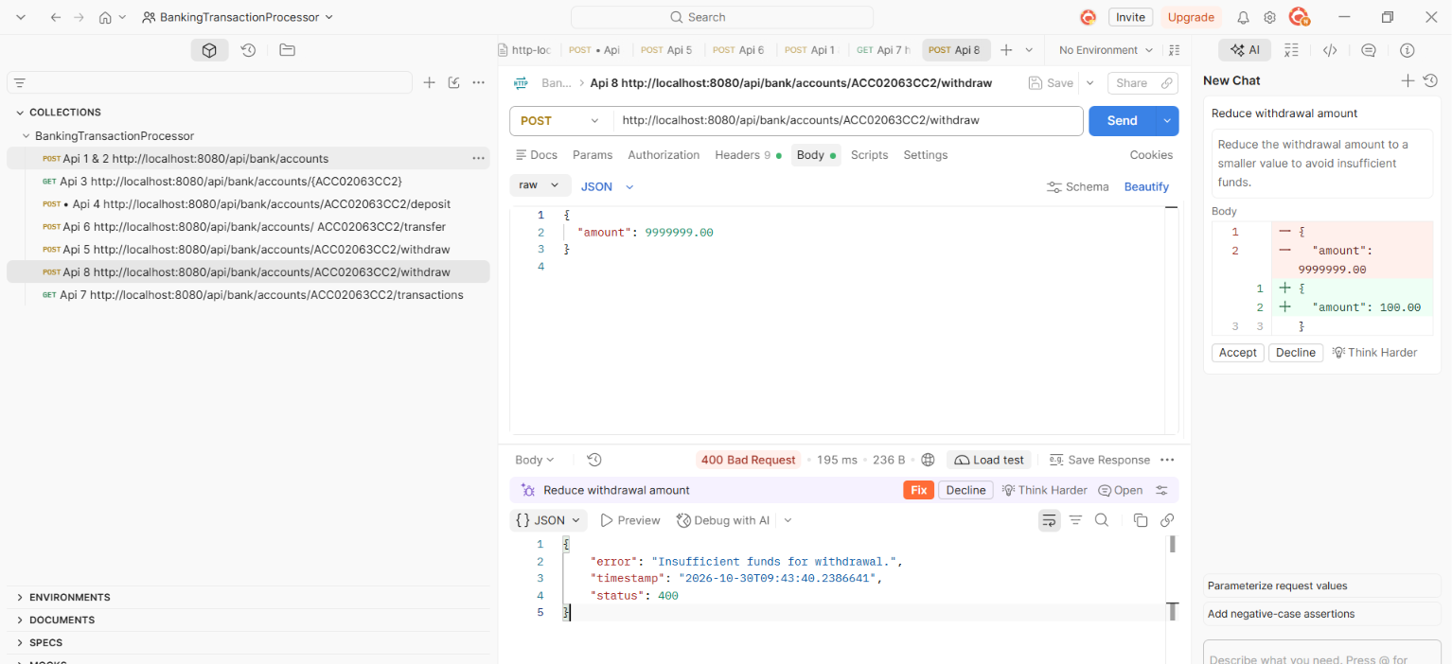

9. Trigger Non-Existent Account (404 Not Found)
- Method: GET
- URL: http://localhost:8080/api/bank/accounts/ACC_INVALID_999

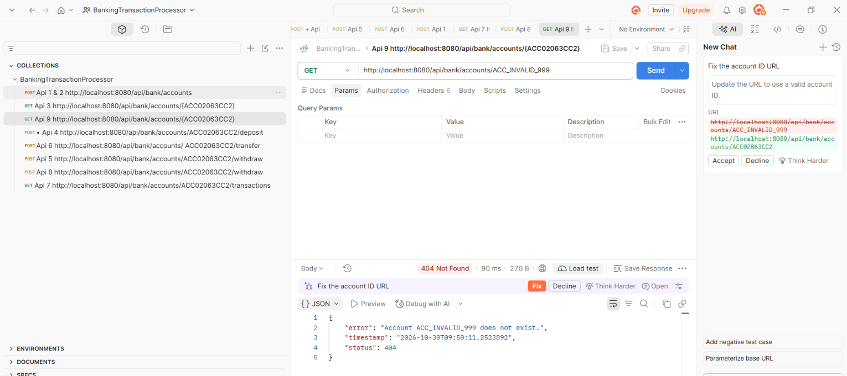

Further Steps

- Creating security using spring-starter-security plugin and creating jwt tokens for the user logged in .
- Maintain session for the token for standard expiry time.
- Create a docker image and use that to deploy the microsevices to Kubernetes.
- Also can use Aws EKS.
- Write uni test cases using junit and Mockito.

